**Connecting to the WinMax Control using a Vendor ID and WCF Data Services**

Hurco Companies, Inc.

**Record of Changes**

|  |  |  |  |
| --- | --- | --- | --- |
| Rev. | Revision Description | Rev By | Date |
| 1 | Original Release | Ian Roberts,  Paul Gray | 2016.03.28 |
|  |  |  |  |
|  |  |  |  |
|  |  |  |  |
|  |  |  |  |
|  |  |  |  |
|  |  |  |  |
|  |  |  |  |
|  |  |  |  |

**Introduction**

This document refers to the software provided in the sample integration package. This connection is only available on Mill machines running v9 or higher control software and is presently not available on Lathes.

To connect to the Mill machines, the host CNC machine will need the Ultimonitor option along with the specific Vendor’s Option. The Vendor will embed their Vendor ID and Vendor Password in their connection software as shown in the sample integration below. The Hurco control validates the connection based on this data and the presence of the Vendor Option.

1. **Add the SIDs for the data you require to the list in the file SidConstants.cs**  
   SIDs are named Source IDs that your application subscribes to from the Hurco control. Your application will be pushed the associated data from the SIDs when the data changes.

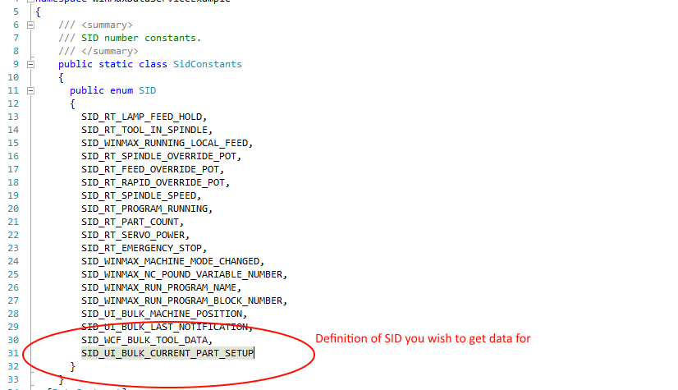

1. **Add those SIDs to the list that the application will subscribe to**

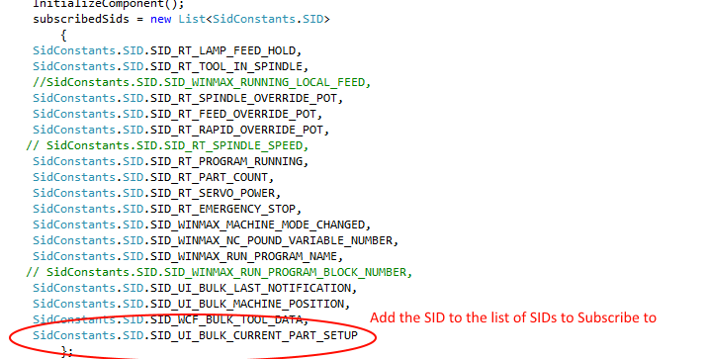

1. **Initialize the connections to WinMax.**Here the sample integration uses an IP address from a textbox.

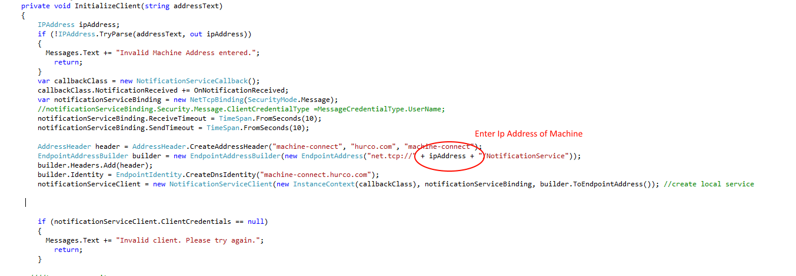

1. **Set your Vendor ID and Password**Your Vendor ID and Password are issued by Hurco

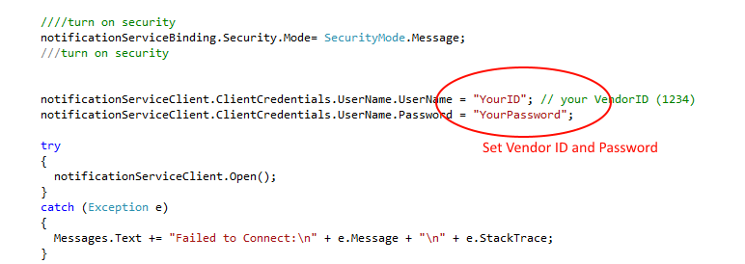

1. **Subscribe to the SIDs from the list of subscription SIDs**

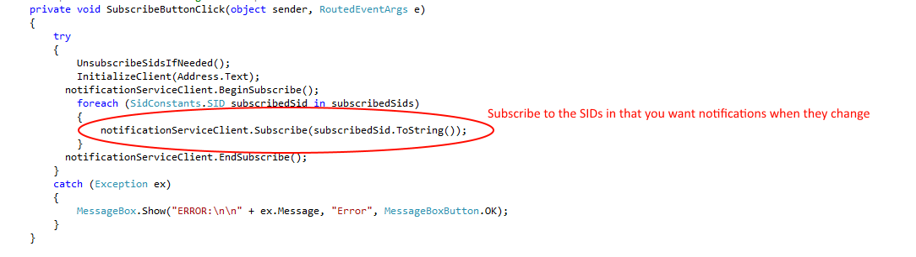

1. **Handle updates to the subscribed SIDs**

* eventArgs.Sid = name of SID
* eventArgs.Value = value of SID as string
  + if SID is a bulk will be a JSON string representing the bulk

